## Study area

We sampled crab assemblages, eelgrass biometrics, and sea otter density along the west coast of Prince of Wales Island and nearby islands in Alaska, with sites ranging 93 km from the most southern site in Dunbar Inlet up to the most northern site in Naukati Bay (Figure 1). Sites were sampled from April to August during 2017–2020. Sites were selected following methods described in Raymond et al. (2021), briefly summarized here. We used the ShoreZone database and site visits to identify coastline segments with 100 m of eelgrass habitat with no overlapping kelp canopy (Harper & Morris, 2014, National Oceanic and Atmospheric Administration, 2021). Crab abundance and size composition and sea otter density were quantified at 21 sites in 2017 and 2020, 22 sites in 2019, and 6 sites in 2018. Eelgrass biometrics were sampled at 21 sites in 2017, 6 sites in 2018, 19 sites in 2019, and 6 sites in 2020 (Figure 1).

*Crab assemblage data*

Crab assemblages were sampled May–August from 2017 through 2020. Crabs were sampled by setting 3–4 replicate strings of baited crab pots for 24 hrs at approximately 3-m depth Mean Lower Low Water (MLLW) in eelgrass habitat. Each string consisted of two pots, one of each style, to target a range of crab sizes: (1) a foldable wire mesh box pot (61 x 61 x 33 cm) with 10 x 10-cm gridding and two 20 x 10-cm openings, and (2) a collapsible ‘fukui’ style pot (60 x 45 x 20 cm) with 1 x 1-cm fabric mesh and two 10 cm openings (Figure 3). Pots were connected with 3-m lead line and marked at the surface with a single buoy. All pots were baited with ~0.5 l of chopped, frozen Pacific herring *Clupea pallasii*. Upon retrieval of pots, crabs were identified to species, their carapace width measured to the nearest millimeter at the widest part, and their sex identified (Figure 2). Species identification discrepancies between *C. magister* and *C. gracilis* led us to drop 2017 and 2018 data from analyses for these species. Each site was visited once per year. To standardize data and compare across years, crab abundance and biomass were converted to catch per unit effort (CPUE) and biomass per unit effort (BPUE) per species, with catch calculated as the sum of crab species per site per year and biomass the sum of biomass per species per site per year. Effort was the number of pots per site per year. Because the larger wire mesh pot captured few crabs, CPUE and BPUE were based on the fukui pot samples only, with three pots per site in 2017 and 2020, and four pots per site in 2019 and 2020. Crab carapace width was used as a metric of crab size. Carapace widths were converted to mass using species-specific conversion factors (a and b, Table S1.2) using Eq. 1.1:

(1.1)

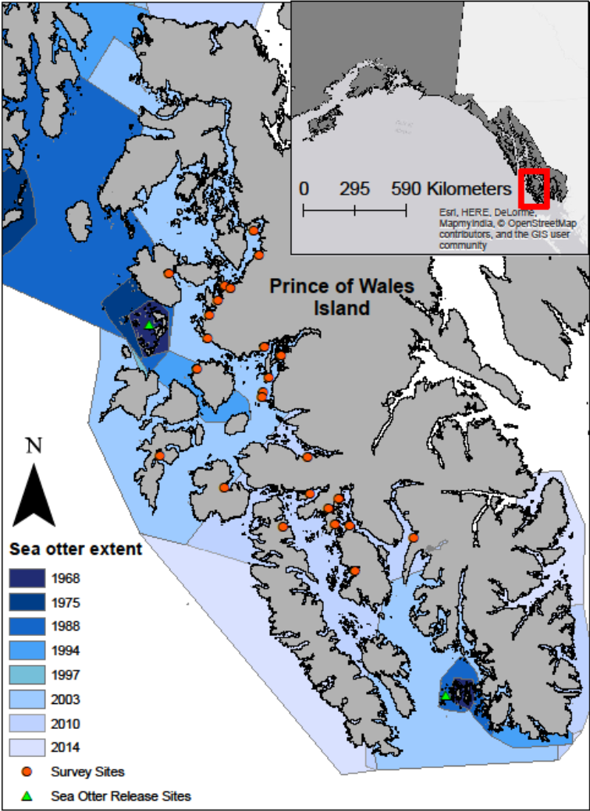

Figure 1 – Study area in Southeast Alaska near Prince of Wales Island. Orange circles indicate sample sites, green triangles indicate sea otter reintroduction sites, and sea otter colonization through time is color coded by year (blue).



Figure 2 – Measure crab carapace width of a red rock crab (Cancer productus).

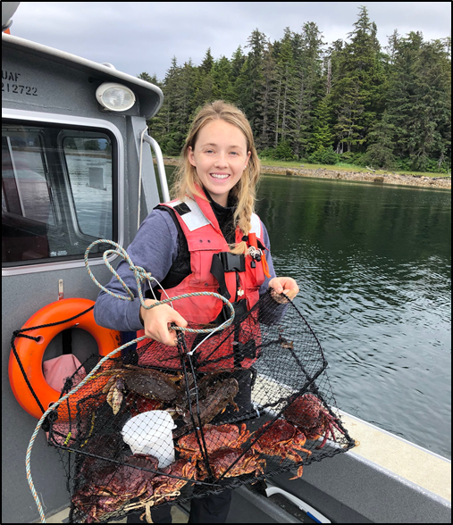

Figure 3 – Posing with a collapsible ‘fukui’ style pot pulled up at site North Fish Egg Island. Pot contains red rock crab (C. productus) and Dungeness crab (Cancer magister).

## Literature Cited

Harper JR, Morris M (2014) Alaska ShoreZone coastal habitat mapping protocol. Nuka Research and Planning Group, LLC.

National Oceanic and Atmospheric Administration (2021) ShoreZone.

Raymond WW, Hughes BB, Stephens TA, Mattson CR, Bolwerk AT, Eckert GL (2021) Testing the generality of sea otter-mediated trophic cascades in seagrass meadows. Oikos 130:725–738.